INVENTORY MANAGEMENT SYSTEM
A MINI-PROJECT REPORT
Submitted by

baskar a 240701074
PRAGADEESH S 240701388
JOBESON J 240701217

in partial fulfillment of the award of the degree
of
BACHELOR OF ENGINEERING
IN
COMPUTER SCIENCE AND ENGINEERING


RAJALAKSHMI ENGINEERING COLLEGE, CHENNAI
An Autonomous Institute
CHENNAI
NOVEMBER 2025

BONAFIDE CERTIFICATE

Certified that this project “INVENTORY MANAGEMENT SYSTEM FOR RETAIL SHOP” is the Bonafide work of “BASKAR A ,PRAGADEESH S and JOBESON J” who carried out the project work under my supervision.

SIGNATURE
S.ADHITHYAN
ASSISTANT PROFESSOR SG
Dept. of Computer Science and Engg,
Rajalakshmi Engineering College
Chennai

This mini project report is submitted for the viva voce examination to be held on __________

INTERNAL EXAMINER EXTERNAL EXAMINER

ABSTRACT

The Inventory Management System is designed to help retail shop owners manage their stock efficiently and automate the billing process. The system allows the user to log in, view products, generate bills, and automatically update stock levels after each sale. When a product runs out, the system marks it as “Out of Stock.”
Developed using Java (Swing) for the front end, MySQL for the backend, and JDBC for connectivity, this project provides a simple yet powerful solution for small retail shops to maintain accurate stock and sales records.

ACKNOWLEDGEMENT

We express our sincere thanks to our beloved and honorable chairman MR. S. MEGANATHAN and the chairperson DR. M.THANGAM MEGANATHAN for their timely support and encouragement.
We are greatly indebted to our respected and honorable principal
Dr. S.N. MURUGESAN for his able support and guidance.
No words of gratitude will suffice for the unquestioning support extended to us by our Head Of The Department Dr. E.M. MALATHY and our Deputy Head Of The Department Dr. J. MANORANJINI for being ever supporting force during our project work
We also extend our sincere and hearty thanks to our internal guide S.ADHITHYAN, for her valuable guidance and motivation during the completion of this project.
Our sincere thanks to our family members, friends and other staff members of computer science engineering.

BASKAR A
PRAGADEESH S
JOBESON J

TABLE OF CONTENTS

- CHAPTER NO | - TITLE | - PAGE NO
- ABSTRACT |  | - iv
- 1 | - INTRODUCTION | - 1
- 1.1 | - INTRODUCTION | - 1
- 1.2 | - SCOPE OF THE WORK | - 2
- 1.3 | - PROBLEM STATEMENT | - 2
- 1.4 | - AIM AND OBJECTIVES | - 2
- 2 | - SYSTEM SPECIFICATIONS | - 3
- 2.1 | - HARDWARE SPECIFICATIONS | - 3
- 2.2 | - SOFTWARE SPECIFICATIONS | - 3
- 3 | - MODULE DESCRIPTION | - 4
- 4 | - CODING | - 6
- 5 | - SCREENSHOTS | - 14
- 6 | - CONCLUSION AND FUTURE ENHANCEMENT | - 17
 | - REFERENCES | - 18

CHAPTER 1
INTRODUCTION
  - INTRODUCTION
The Inventory Management System for a retail shop simplifies daily sales and product tracking activities. It helps store owners keep accurate records of stock quantities, item prices, and billing. The system automatically updates product availability and flags “Out of Stock” items, improving efficiency and reducing manual errors.

  - SCOPE OF THE WORK
This project helps retail shops move from manual stock entry and billing to an automated system. It provides a user-friendly interface for product lookup, billing, and stock maintenance. The system ensures that product information, pricing, and availability are always accurate.

  - PROBLEM STATEMENT
Most small retail shops still depend on manual methods to manage inventory and generate bills. This leads to human error, delays, and inaccurate stock counts. A digital system is required to handle real-time updates, billing, and product monitoring efficiently.
1.4 AIM AND OBJECTIVES OF THE PROJECT
- To create a user-friendly interface for managing retail inventory.
- To provide secure login access for authorized users.
- To generate bills and update product quantities automatically.
- To alert users when products are out of stock.

CHAPTER 2
SYSTEM SPECIFICATIONS
2.1 HARDWARE SPECIFICATIONS
Component | Specification
Processor | Intel Core i3 / i5
Memory | 4 GB RAM (minimum)
Hard Disk | 10 GB free space
Display | 1024×768 pixels (minimum)
2.2 SOFTWARE SPECIFICATIONS
Component Specification
Operating system Windowa 10/11
Front end Java(Swing GUI)
Back end MySQL
Connectivity JDBC(java database connectivity)
IDE IntelliJ IDEA community edition
CHAPTER 3
MODULE DESCRIPTION
T his application consists of two modules.
- Login Module
- Allows the user to log in using a username and password.
- On successful login, opens the billing window.
- Prevents unauthorized access.
2. Billing Module
- Accepts product ID and quantity.
- Fetches product name, price, and stock from the database.
- Displays “Out of Stock” when stock = 0.
- Updates quantity after each sale and calculates the total bill.

CHAPTER 4
SAMPLE CODING
Database Setup Example:
CREATE DATABASE inventorydb;
USE inventorydb;
CREATE TABLE products ( id INT AUTO_INCREMENT PRIMARY KEY, name VARCHAR(100) NOT NULL, category VARCHAR(50), quantity INT NOT NULL DEFAULT 0, price DECIMAL(10,2) NOT NULL DEFAULT 0.00, created_at TIMESTAMP DEFAULT CURRENT_TIMESTAMP );
USE inventorydb;
DESC products;
INSERT INTO products (name, category, quantity, price)
VALUES
('Milk', 'Dairy', 40, 25.00),
('Bread', 'Bakery', 60, 30.00),
('Eggs', 'Grocery', 100, 6.00),
('Sugar', 'Grocery', 80, 45.00),
('Tea Powder', 'Beverages', 50, 120.00),
('Coffee', 'Beverages', 40, 150.00),
('Biscuits', 'Snacks', 70, 15.00),
('Wheat Flour', 'Grocery', 90, 55.00),
('Cooking Oil', 'Grocery', 60, 160.00),
('Toothpaste', 'Toiletries', 50, 65.00),
('Toothbrush', 'Toiletries', 75, 25.00),
('Detergent', 'Household', 45, 90.00),
('Shampoo', 'Toiletries', 35, 85.00),
('Soap', 'Toiletries', 80, 25.00),
('Rice', 'Grocery', 100, 60.00);

Sample 1: Login page
package com.inventory.ui;
import javax.swing.*;
import java.awt.*;
import java.awt.event.*;
public class LoginFrame extends JFrame {
private JTextField txtUsername;
private JPasswordField txtPassword;
private JButton btnLogin, btnClear;
// hardcoded credentials
private static final String USERNAME = "dbms";
private static final String PASSWORD = "rec123";
public LoginFrame() {
setTitle("🔐 Inventory Management Login");
setSize(450, 350);
setLocationRelativeTo(null);
setDefaultCloseOperation(JFrame.EXIT_ON_CLOSE);
// Colors
Color primaryColor = new Color(52, 152, 219);
Color accentColor = new Color(41, 128, 185);
Color buttonColor = new Color(46, 204, 113);
Color textColor = Color.WHITE;
// Background gradient panel
JPanel bgPanel = new JPanel() {
@Override
protected void paintComponent(Graphics g) {
super.paintComponent(g);
Graphics2D g2d = (Graphics2D) g;
GradientPaint gp = new GradientPaint(0, 0, primaryColor, getWidth(), getHeight(), accentColor);
g2d.setPaint(gp);
g2d.fillRect(0, 0, getWidth(), getHeight());
}
};
bgPanel.setLayout(new GridBagLayout());
add(bgPanel);
// Card-style panel
JPanel panel = new JPanel(new GridBagLayout());
panel.setPreferredSize(new Dimension(320, 220));
panel.setBackground(Color.WHITE);
panel.setBorder(BorderFactory.createLineBorder(primaryColor, 2, true));
GridBagConstraints gbc = new GridBagConstraints();
gbc.insets = new Insets(10, 10, 10, 10);
gbc.fill = GridBagConstraints.HORIZONTAL;
JLabel lblTitle = new JLabel("LOGIN", SwingConstants.CENTER);
lblTitle.setFont(new Font("Segoe UI", Font.BOLD, 22));
lblTitle.setForeground(primaryColor);
gbc.gridx = 0;
gbc.gridy = 0;
gbc.gridwidth = 2;
panel.add(lblTitle, gbc);
gbc.gridwidth = 1;
JLabel lblUsername = new JLabel("Username:");
lblUsername.setFont(new Font("Segoe UI", Font.PLAIN, 14));
gbc.gridx = 0;
gbc.gridy = 1;
panel.add(lblUsername, gbc);
txtUsername = new JTextField(15);
txtUsername.setFont(new Font("Segoe UI", Font.PLAIN, 14));
gbc.gridx = 1;
gbc.gridy = 1;
panel.add(txtUsername, gbc);
JLabel lblPassword = new JLabel("Password:");
lblPassword.setFont(new Font("Segoe UI", Font.PLAIN, 14));
gbc.gridx = 0;
gbc.gridy = 2;
panel.add(lblPassword, gbc);
txtPassword = new JPasswordField(15);
txtPassword.setFont(new Font("Segoe UI", Font.PLAIN, 14));
gbc.gridx = 1;
gbc.gridy = 2;
panel.add(txtPassword, gbc);
btnLogin = new JButton("Login");
btnLogin.setBackground(buttonColor);
btnLogin.setForeground(textColor);
btnLogin.setFont(new Font("Segoe UI", Font.BOLD, 14));
btnLogin.setFocusPainted(false);
gbc.gridx = 0;
gbc.gridy = 3;
gbc.gridwidth = 1;
panel.add(btnLogin, gbc);
btnClear = new JButton("Clear");
btnClear.setBackground(new Color(231, 76, 60));
btnClear.setForeground(textColor);
btnClear.setFont(new Font("Segoe UI", Font.BOLD, 14));
btnClear.setFocusPainted(false);
gbc.gridx = 1;
gbc.gridy = 3;
panel.add(btnClear, gbc);
bgPanel.add(panel);
// Action listeners
btnLogin.addActionListener(e -> attemptLogin());
btnClear.addActionListener(e -> clearFields());
// Enter key triggers login
txtPassword.addKeyListener(new KeyAdapter() {
@Override
public void keyPressed(KeyEvent e) {
if (e.getKeyCode() == KeyEvent.VK_ENTER) attemptLogin();
}
});
}
private void attemptLogin() {
String username = txtUsername.getText().trim();
String password = new String(txtPassword.getPassword());
if (username.isEmpty() || password.isEmpty()) {
JOptionPane.showMessageDialog(this, "Please enter username and password.", "Missing", JOptionPane.WARNING_MESSAGE);
return;
}
// Hardcoded credential check
if (USERNAME.equals(username) && PASSWORD.equals(password)) {
JOptionPane.showMessageDialog(this, "✅ Login successful!");
// open billing and close login
SwingUtilities.invokeLater(() -> {
new BillingFrame().setVisible(true);
});
dispose();
} else {
JOptionPane.showMessageDialog(this, "❌ Invalid username or password.", "Login Failed", JOptionPane.ERROR_MESSAGE);
txtPassword.setText("");
txtUsername.requestFocus();
}
}
private void clearFields() {
txtUsername.setText("");
txtPassword.setText("");
txtUsername.requestFocus();
}
public static void main(String[] args) {
SwingUtilities.invokeLater(() -> new LoginFrame().setVisible(true));
}
}

Sample 2
Sample 2 depicts the billing page
package com.inventory.ui;
import javax.swing.*;
import javax.swing.table.DefaultTableModel;
import java.awt.*;
import java.awt.event.ActionEvent;
import java.awt.event.ActionListener;
import java.sql.Connection;
import java.sql.PreparedStatement;
import java.sql.ResultSet;
import java.sql.SQLException;
public class BillingFrame extends JFrame {
private JTextField txtProductName, txtQuantity;
private JTable table;
private DefaultTableModel model;
private JLabel lblGrandTotal;
private double grandTotal = 0;
public BillingFrame() {
setTitle("🛒 Inventory Billing System");
setSize(850, 600);
setLocationRelativeTo(null);
setDefaultCloseOperation(JFrame.EXIT_ON_CLOSE);
setLayout(new BorderLayout());
// ---- Colors ----
Color headerColor = new Color(52, 152, 219);
Color bgColor = new Color(245, 245, 245);
Color buttonColor = new Color(46, 204, 113);
Color textColor = Color.WHITE;
getContentPane().setBackground(bgColor);
// ---- Top Panel ----
JPanel topPanel = new JPanel(new FlowLayout());
topPanel.setBackground(headerColor);
JLabel lblProduct = new JLabel("Product Name:");
lblProduct.setForeground(textColor);
topPanel.add(lblProduct);
txtProductName = new JTextField(10);
topPanel.add(txtProductName);
JLabel lblQty = new JLabel("Quantity:");
lblQty.setForeground(textColor);
topPanel.add(lblQty);
txtQuantity = new JTextField(5);
topPanel.add(txtQuantity);
JButton btnAdd = new JButton("Add to Bill");
btnAdd.setBackground(buttonColor);
btnAdd.setForeground(textColor);
topPanel.add(btnAdd);
JButton btnPrint = new JButton("Print Bill");
btnPrint.setBackground(new Color(231, 76, 60));
btnPrint.setForeground(textColor);
topPanel.add(btnPrint);
add(topPanel, BorderLayout.NORTH);
// ---- Table ----
String[] columns = {"S.No", "Product Name", "Quantity", "Price", "Total"};
model = new DefaultTableModel(columns, 0);
table = new JTable(model);
table.setRowHeight(25);
table.setBackground(Color.WHITE);
table.setFont(new Font("Segoe UI", Font.PLAIN, 14));
table.getTableHeader().setFont(new Font("Segoe UI", Font.BOLD, 15));
table.getTableHeader().setBackground(headerColor);
table.getTableHeader().setForeground(Color.WHITE);
add(new JScrollPane(table), BorderLayout.CENTER);
// ---- Bottom Panel ----
JPanel bottomPanel = new JPanel(new FlowLayout(FlowLayout.RIGHT));
bottomPanel.setBackground(bgColor);
lblGrandTotal = new JLabel("Grand Total: ₹0.00");
lblGrandTotal.setFont(new Font("Segoe UI", Font.BOLD, 18));
lblGrandTotal.setForeground(new Color(39, 174, 96));
bottomPanel.add(lblGrandTotal);
add(bottomPanel, BorderLayout.SOUTH);
// ---- Button Actions ----
btnAdd.addActionListener(new ActionListener() {
@Override
public void actionPerformed(ActionEvent e) {
addProductToBill();
}
});
btnPrint.addActionListener(e ->
JOptionPane.showMessageDialog(this, "🖨️ Print functionality coming soon!")
);
}
private void addProductToBill() {
String productName = txtProductName.getText().trim();
String qtyText = txtQuantity.getText().trim();
if (productName.isEmpty() || qtyText.isEmpty()) {
JOptionPane.showMessageDialog(this, "Please enter product name and quantity!");
return;
}
int enteredQty;
try {
enteredQty = Integer.parseInt(qtyText);
} catch (NumberFormatException e) {
JOptionPane.showMessageDialog(this, "Quantity must be a number!");
return;
}
try (Connection conn = DBConnection.getConnection()) {
String query = "SELECT quantity, price FROM products WHERE name = ?";
PreparedStatement ps = conn.prepareStatement(query);
ps.setString(1, productName);
ResultSet rs = ps.executeQuery();
if (rs.next()) {
int availableQty = rs.getInt("quantity");
double price = rs.getDouble("price");
if (availableQty >= enteredQty) {
double total = price * enteredQty;
grandTotal += total;
model.addRow(new Object[]{
model.getRowCount() + 1,
productName,
enteredQty,
price,
total
});
lblGrandTotal.setText("Grand Total: ₹" + String.format("%.2f", grandTotal));
// Update remaining quantity in DB
String update = "UPDATE products SET quantity = quantity - ? WHERE name = ?";
PreparedStatement psUpdate = conn.prepareStatement(update);
psUpdate.setInt(1, enteredQty);
psUpdate.setString(2, productName);
psUpdate.executeUpdate();
// Clear input fields
txtProductName.setText("");
txtQuantity.setText("");
txtProductName.requestFocus();
} else {
JOptionPane.showMessageDialog(this,
"Only " + availableQty + " items available. Out of stock!");
}
} else {
JOptionPane.showMessageDialog(this, "Product not found!");
}
} catch (SQLException ex) {
JOptionPane.showMessageDialog(this, "Database error: " + ex.getMessage());
}
}
public static void main(String[] args) {
SwingUtilities.invokeLater(() -> new BillingFrame().setVisible(true));
}
}

CHAPTER 5
SCREEN SHOTS
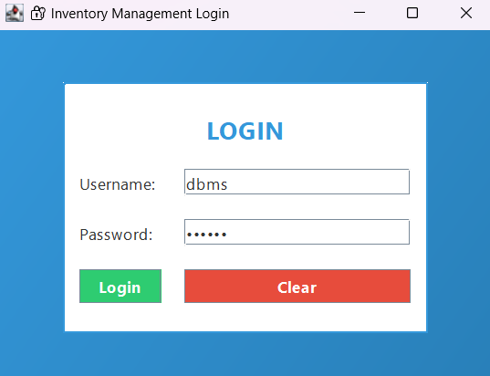
Fig 5.1 Login page
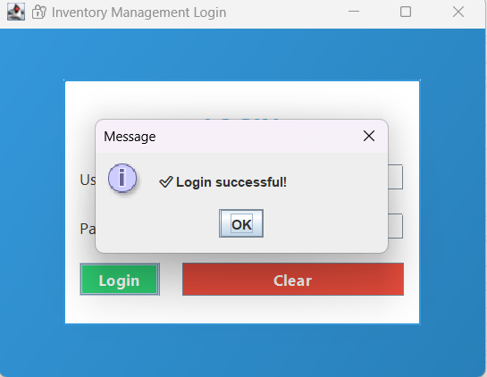
Fig 5.2 Login page
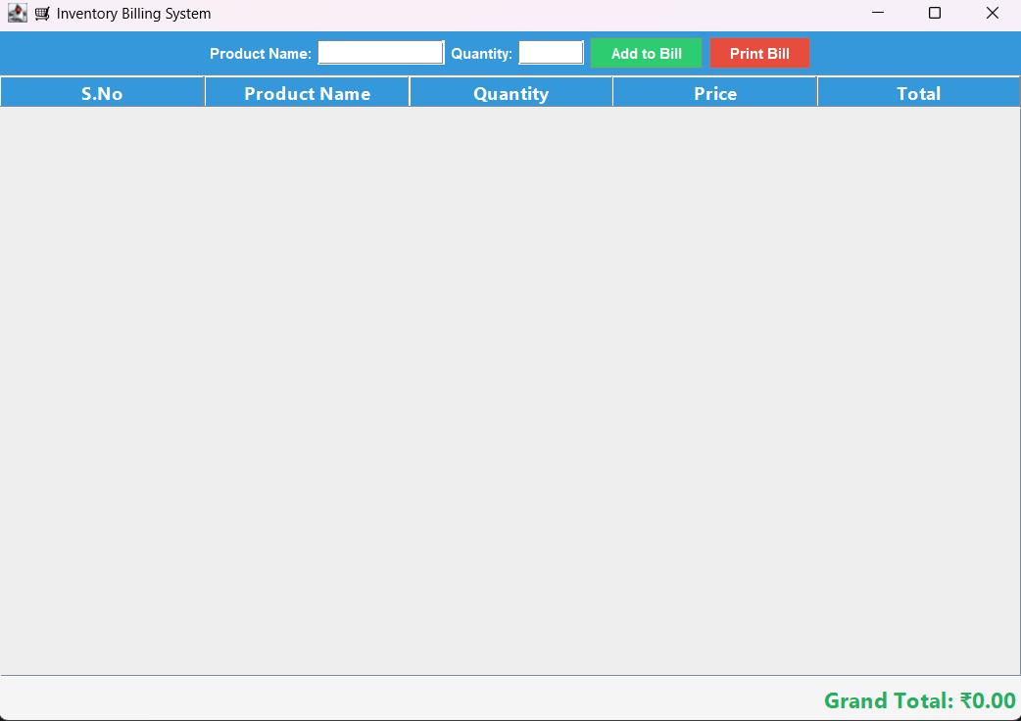
Fig 5.3 Billing page

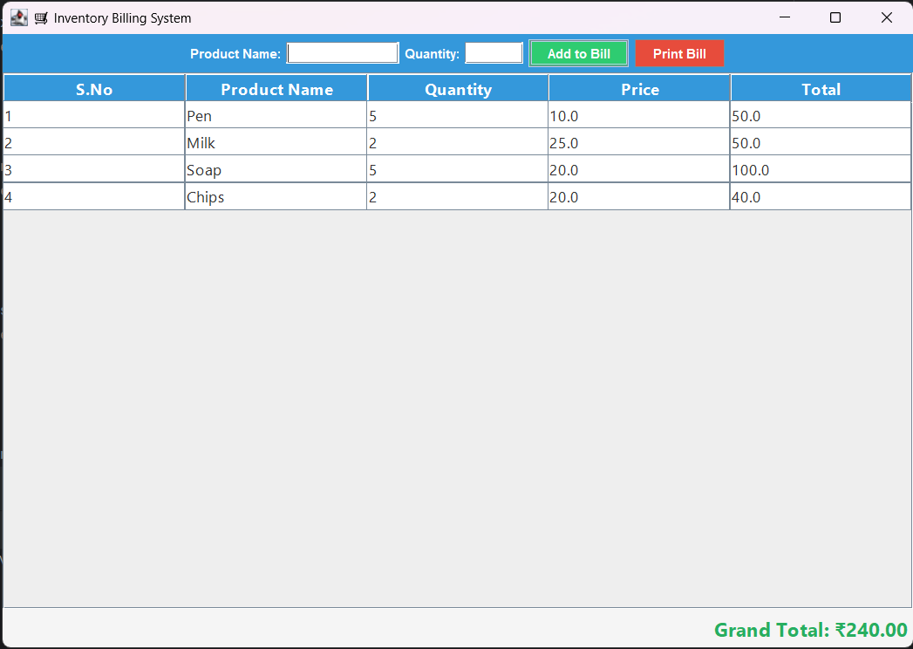
Fig 5.4 Billing page
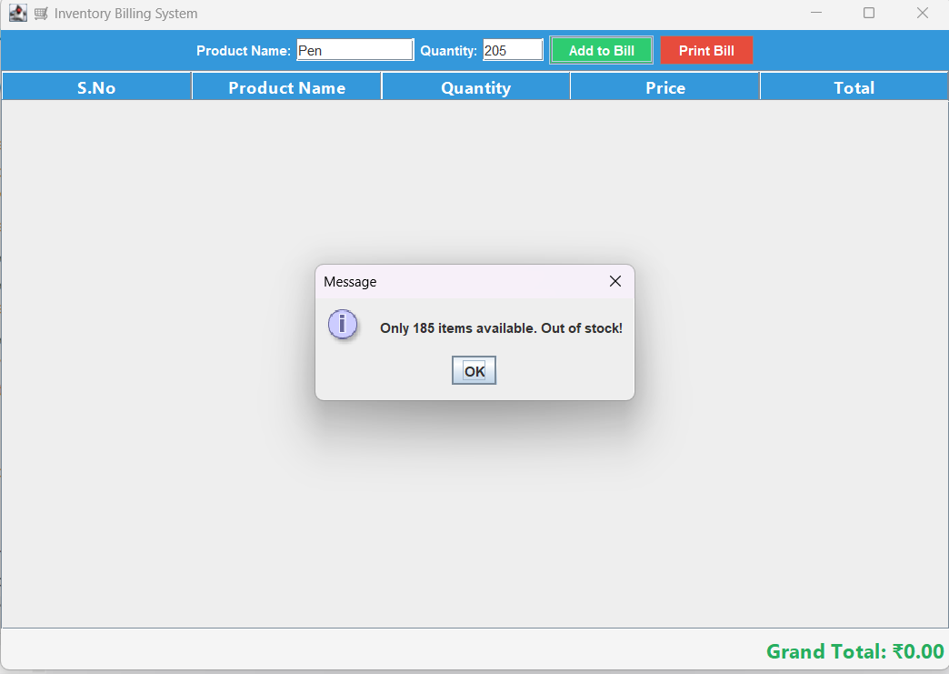
Fig 5.5 Out of stock checking
CHAPTER 6
CONCLUSION AND FUTURE ENHANCEMENT
This Inventory Management System provides a reliable and efficient solution for retail shops to manage their stock and billing processes. It reduces manual work and errors, providing real-time product availability updates.
Future Enhancements:
- Integration of barcode scanning for faster billing.
- Generating sales reports and analytics.
- Adding multi-user roles (admin, cashier).
- Cloud-based database for remote shop access.

REFERENCES

- https://www.w3schools.com/java/
- https://www.mysql.com/
- https://www.geeksforgeeks.org/jdbc/
- https://docs.oracle.com/javase/tutorial/

